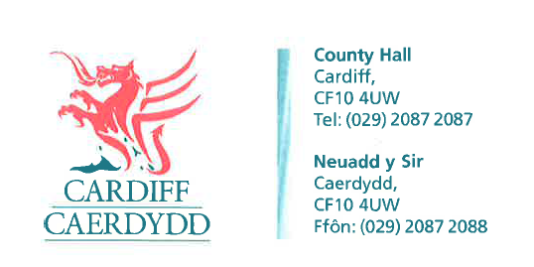
FOI Response Document
FOI6571
Thank you for your request under the Freedom of Information Act 2000 about Location of potential EV Charging Sites in “All Wales EV Chargepoint Framework Agreement” received on 06/08/2021.
Request
Please provide me with the locations including, as available, full address, postcode and/or latitude/longitude for the sites/ the 'estimated sites' listed in the procurement notice as follows:
The estimated number of sites with one dual chargepoint at each site is currently:
- Wrexham 5
- Swansea 44
- Pembrokeshire 23
- Newport CC 10
- Gwynedd 92
- Carmarthenshire 15
- Cardiff 50
- TfW Railway Station 350
- Powys 50
- Denbeighshire 12
- Cardigan 12
- Other 150
We have considered your request and enclose the following information:
Response: Please see Attachment 1. Under Section 16 of the Freedom of Information Act 2000 we have a duty to advise and assist our customers, as such please note that the information provided has not been finalised and is only proposed sites. These sites may change during the course of investigation/works.
Please also note that Cardiff Council only deals with the Cardiff Capital Region and not the rest of Wales. It does not hold any information outside of the Cardiff Capital Region. As such the information provided is only for the area that Cardiff Council covered.
If you have any queries or concerns, please do not hesitate to contact us.
Please remember to quote the reference number above in any future communications.

